COMMUNITY LAW RESOURCES ASSOCIATION
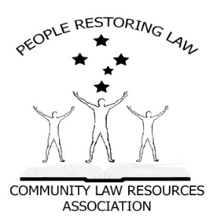 Some Facts.
IS N.S.W. LOCAL GOVERNMENT VALID?

PRESS RELEASE
- All Parliaments require authority from somewhere to make Laws.
- Where does the NSW Parliament receive its authority from?
- Answer; the NSW Constitution s5 and the Commonwealth Constitution section 108.
- The NSW Constitution is subject to the Commonwealth Constitution Section106.
Local Government relies on the Local Government Act 1993 (NSW) for its existence.
- The Local Government Act 1993 (NSW) relies on s51 of the NSW Constitution for its existence.
- Municipal institutions and local government, is in the Commonwealth Constitution as a department of a State Government. (Pages 935 & 936 Annotated Constitution).
- In 1986, The Parliament of NSW amended the NSW Constitution to in include s51 which inserts Local Government into the NSW Constitution.
Some questions.
- Can the Parliament of NSW amend the Commonwealth Constitution? NO. Only the people of the Commonwealth can do that by means of s128 (referendum) of such Constitution.

Can the Parliament of NSW create any Laws that are inconsistent with the Commonwealth Constitution? NO. section 106 & 108 Commonwealth Constitution.
Some more Facts.
- Therefore, s51 of the NSW Constitution is unlawful and, as a result, so is the Local Government Act 1993 and, consequently, so is Local Government as a Government.
- Local Government can only be a Department of a State, and Departments of State Governments cannot govern us, cannot create Laws (Local Laws) and above all cannot Tax us (Rates).
- Municipal institutions and local government are in the Commonwealth Constitution, as a department of a State Government. In 1993, the NSW Parliament altered its Constitution to include a 3rd or an essential tier of Government which has effectively altered or is at least repugnant to the Commonwealth Constitution.
Statement
Local Government cannot govern us, cannot make laws for us (local law) and cannot tax us (rates).
Municipal institutions and local governments can only be a Department of a State, just like the Education Department or the Health Department.
Now the question for all NSW State politicians is:
In 1986, where did the NSW Parliament get its authority from to alter or at least make laws (their Constitution) that are repugnant to the Commonwealth Constitution?

