COMMUNITY LAW RESOURCES ASSOCIATION
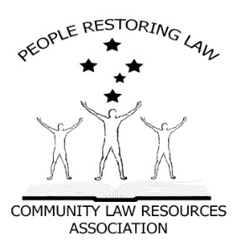 Some Facts.
IS QUEENSLAND LOCAL GOVERNMENT VALID?

PRESS RELEASE
- All Parliaments require authority from somewhere to make Laws.
- Where does the Queensland Parliament receive its authority from?
- Answer; the Queensland Constitution s8 and the Commonwealth Constitution s108.
- The Queensland Constitution is subject to the Commonwealth Constitution s106.
- Local Government relies on the Local Government Act 2009 (Qld) for its existence.
- The Local Government Act 2009 (Qld) relies on s70 of the Queensland Constitution for its existence.
- Municipal institutions and local government, is in the Commonwealth Constitution as a department of a State Government. (Pages 935 & 936 Annotated Constitution).
- In 1989,The Parliament of Queensland amended the Queensland Constitution to include s54-56 which inserts Local Government into the Queensland Constitution.
Some questions.
- Can the Parliament of Queensland amend the Commonwealth Constitution? NO. Only the people of the Commonwealth can do that by means of s128 (referendum) of such Constitution.

Can the Parliament of Queensland create any Laws that are inconsistent with the Commonwealth Constitution? NO. section 106 & 108 Commonwealth Constitution.
Some more Facts.
- Therefore, s54-56 of the Queensland Constitution is unlawful and, as a result, so is the Local Government Act 2009 and, consequently, so is Local Government as a Government.
- Local Government can only be a Department of a State, and Departments of State Governments cannot govern us, cannot create Laws (Local Laws) and above all cannot Tax us (Rates).
- Municipal institutions and local government are in the Commonwealth Constitution, as a department of a State Government. In 1989, the Queensland Parliament altered its Constitution to include a 3rd or an essential tier of Government which has effectively altered or is at least repugnant with the Commonwealth Constitution.
Statement
Local Government cannot govern us, cannot make laws for us (local law) and cannot tax us (rates).

Municipal institutions and local governments can only be a Department of a State, just like the Education Department or the Health Department.
Now the question for all Queensland State politicians is:
In 1989, where did the Queensland Parliament get its authority from to alter or at least make laws that are repugnant to the Commonwealth Constitution?

