COMMUNITY LAW RESOURCES ASSOCIATION
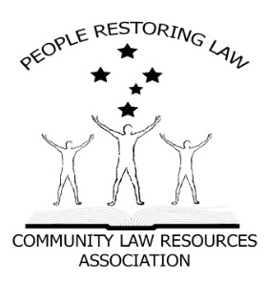 Some Facts.
IS SOUTH AUSTRALIAN LOCAL GOVERNMENT VALID?

PRESS RELEASE
- All Parliaments require authority from somewhere to make Laws.
- Where does the South Australian Parliament receive its authority from?
- Answer; the South Australian Constitution s5 and the Commonwealth Constitution s108.
- The South Australian Constitution is subject to the Commonwealth Constitution s106.
- Local Government relies on the Local Government Act 1999 (SA) for its existence.
- The Local Government Act 1999 (SA) relies on s64A of the South Australian Constitution for its existence.
- Municipal institutions and local government, is in the Commonwealth Constitution as a department of a State Government. (Pages 935 & 936 Annotated Constitution).
- In 1980, The Parliament of South Australian amended the South Australian Constitution Act 1934 by creating s64A which inserts Local Government into the South Australian Constitution.
Some questions.
- Can the Parliament of South Australian amend the Commonwealth Constitution? NO. Only the people of the Commonwealth can do that by means of s128 (referendum) of such Constitution.

Can the Parliament of South Australian create any Laws that are inconsistent with the Commonwealth Constitution? NO. section 106 & 108 Commonwealth Constitution.
Some more Facts.
- Therefore, s64a of the South Australian Constitution is unlawful and, as a result, so is the Local Government Act 1999 and consequently, so is Local Government as a Government.
- Local Government can only be a Department of a State, and Departments of State Governments cannot govern us, cannot create Laws (Local Laws) and, above all, cannot Tax us (Rates).
- Municipal institutions and local government are in the Commonwealth Constitution, as a department of a State Government. The South Australian Parliament altered its Constitution to include a 3rd or an essential tier of Government, which has effectively altered or is at least repugnant to the Commonwealth Constitution.
Statement
Local Government cannot govern us, cannot make laws for us (local law) and cannot tax us (rates).

Municipal institutions and local governments can only be a Department of a State, just like the Education Department or the Health Department.
Now the question for all South Australian State politicians is:
In 1980, where did the South Australian Parliament get its authority from to alter or at least make laws that are repugnant to the Commonwealth Constitution?

